**Phượng M. Đỗ: The Puzzle of Life and Photography, or What Fits and What Not**

*Author: Đồng Hà Nhuận (Ha Nhuan Dong) 05/2021-10/2021*

Last year, I embarked on a two-month research that sought to sketch a possible genealogy of “Vietnamese contemporary art” that foregrounds female art practitioners.Spanning two print issues of a magazine, roughly twenty-one pages, the final essay celebrates more than twenty figures of diverse practices, either Vietnamese or not, who I found were, and are, prominent to the local art scene.1 In retrospect, however, I have to admit: it was too ambitious to do justice to the topic, especially within that timeframe.2 In short, too many people, too little space and time. Now, to further my inquiry, and yours as well I hope, from the premise of that starting point, I shall turn to the individuals that make up the possibility of such a genealogy in the first place.

During that process, I stumbled upon *Changing Identity: Recent Works by Women Artists from Vietnam*, a multi-media exhibition curated by Nora Annesley Taylor.3 Traveling across the United States in the mid-2000s, it brought together ten female artists of Vietnamese heritage whose practices ranged from painting and photography to performance, installation, and mixed media.4 There were no explicit unifying themes, although in her brief discussion of the works, Taylor implied that gender, heritage, and war were among the artists’ shared “concerns.”5 She argued that the approach was not to reduce these artistic expressions to a singular style or genre, but to manifest a heterogeneity lied at the intersection of art, women, and Vietnam—three intertwined domains under which these artists were subjected to. The show as a whole, if there was such collective wholeness, was a curated synthesis at best, yet a meaningful one because of its artistic agency and legacy, as it will sure live on beyond its inception.

Specifically, I am moved by the front cover of the exhibition catalogue which speaks to this proactive force that the exhibition and the individual practices possess. From here I encountered the oeuvre of an artist underrepresented in the local discourse of contemporary photography, whose work was printed large on it (as it should): Phượng M. Đỗ.

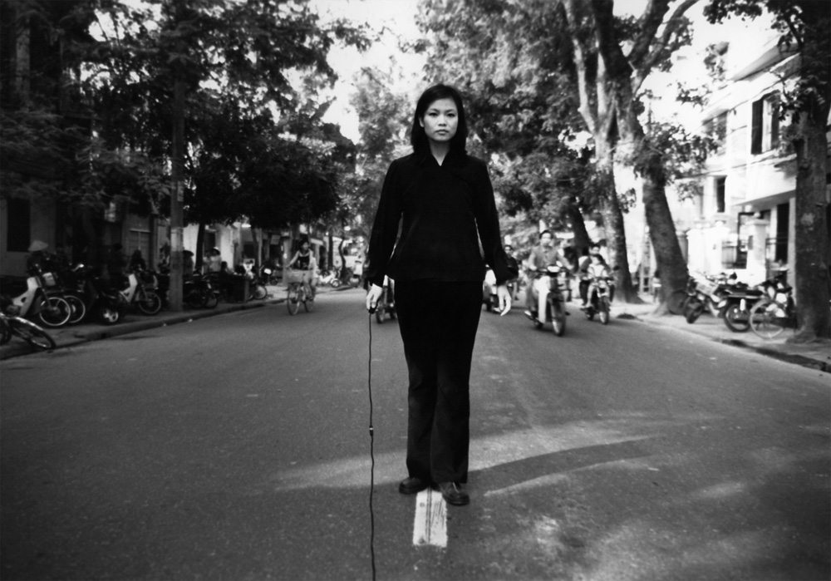

**Phượng M. Đỗ, “hanoi, vietnam, 1998 (self in street),” 1998, Gelatin silver print. 19” x 15”. Courtesy of the artist.**

Born in Laos, Phượng M. Đỗ, or *Đỗ Mỹ Phượng*, is a U.S.-based leadership coach who has had a reparative relationship with photography for more than twenty years.6 Her humble body of work revolves around the self, place, memory, and recently, archival documentation. Raised in the Laotian capital, she later immigrated to America with her immediate family, while some of her relatives stayed in Việt Nam, and some moved to France. In 1988, she earned a Bachelor’s degree in Colorado. In 1991, she landed a professional job in the non-profit sector in Washington, DC where she helped war-impacted Vietnamese, Laotian, Hmong, and Cambodian communities with leadership development. Two years later, she found herself in New York State with another job and eventually finished a Master’s program in Social Work. In 1998, “I just felt like it wasn’t fulfilling,” Đỗ recalled. And so did she turn to photography.

**Family around the table, union in style**

To navigate society is to meander in between loci of social relations. The family, among other societal constituents, is such a site, where these relations are constantly laid bare, constructed and deconstructed. Familial member(-relation-)ship not only imitates external power relations but also presents itself as a framework for society at large. Thus, to place oneself in the family is to situate oneself in the world and vice versa.

Transcending and conjoining identity, kinship, collective memory, and representation, the photographic series *self + family* is Đỗ’s effort to make tangible her relationship with her intercontinentally dispersed extended family and her connection to Việt Nam. An array of black and white and color analogue portraits, *self + family* goes beyond simple addition formulae, not as straightforward as 1 + 1 = 2. It is a site of struggle, between inclusion and exclusion, reconciliation and disconnection.

Đỗ started the project in 1998, boarding to Hà Nội for the first time. The experience was not without difficulties from the start. She felt “numb” sometimes while hesitating to contact her paternal relatives; everything was a first to her. One day, she composed, “the only way I felt that I would feel something was to be in the middle of [the] street.” For her as for many, crossing the traffic in this country was stressful, yet she managed through.7 The artist gave two strange kids some pocket money so they stood on both sides of the tripod, for fear of it being knocked over by passing vehicles. Standing on the line separating traffic lanes, she posed unwavering and resolute, holding the shutter release in one hand, despite all the bikes lurking behind. The black outfit set her in further contrast with the surroundings. In less than five minutes, Đỗ initiated her first engagement with the land and its people through *self in street* (1998).

As she eventually joined her kin in the latter images, she attempted to grasp what it meant to be in a nuclear family of Vietnamese ancestry. How is the family constructed through individuals and their relations? Where does the family locate? And how extended can kinship be?

I presuppose that eating and clothing are two preeminent modes of collectivity, and consequently, belonging, in the Vietnamese family, as evident in this series. On the one hand, eating, as well as drinking, co-exists with gathering (greetings, celebrations, remembrance), talking (stories, gossips, memories), watching TV (commenting, relaxing, debating). These activities often take place indoors, mostly at home—where people unite and (re)connect—so family is often equated with “home,” or “home is where family is.” It is interesting to see here how home or precisely the concept of “family around the table” is trans-border, carried from one country to the next without losing its essence or identification.

On the other hand, clothing is a tool to blend in. Although it can play a divisive role in society, as proven by appearance-based racial/sexist/gender discriminations, what one wears has the potential to mitigate alienation as well. Whether intentional or not, Đỗ’s choice of clothing mirrored and adapted to different contexts, as self-initiated integration. Inclusion as such invites interpersonal reconciliation, although to which degree remains open for debate, to which I shall turn.

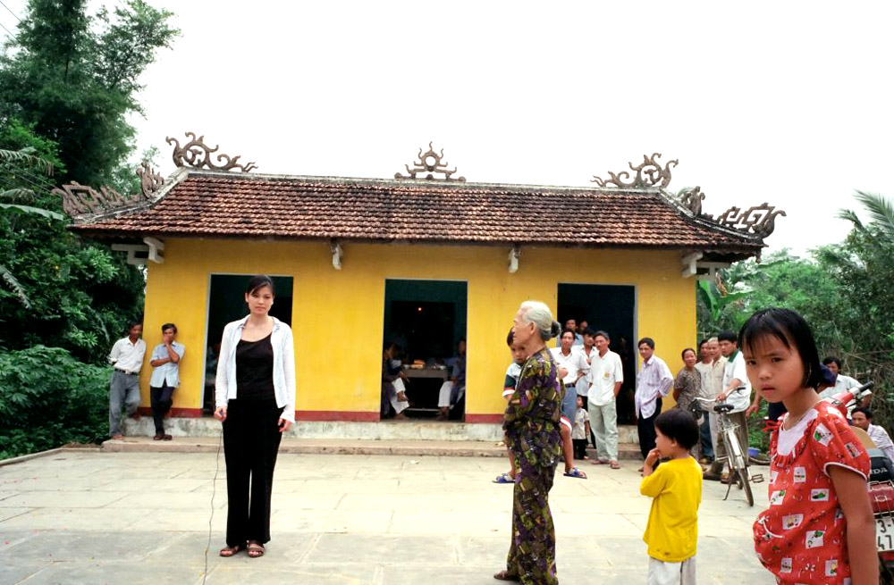

**Phượng M. Đỗ, “la chu, vietnam, 2001 (self with relatives),” 2001, Chromogenic print. 10” x 8”. Courtesy of the artist.**

**Problematizing the political construction of family**

Beyond the personal, the family is a socio-political construction. It is situated at the intersection of politics and history. With inclusion comes exclusion, and belonging, displacement. For instance, there is no guarantee that in the aforementioned interactions, a “crack” would never happen. At one moment peaceful talk proceeds, yet the next, it may erupt into dispute. As a societal micro-organism, the family bears witness to political turmoil and historical disruptions and in turn becomes perpetuated by political intervention. What does it mean, then, to be a part of the family that is socially, culturally, and politically “dismembered” or always likely so?

“This whole disconnect of, you know, place, home, family, is like you drop a mirror and you’re trying to put it back together, so the reflection is sort of fragmented.”

Exile and immigration in the aftermath of political displacement directly contributes to this fragmentation. The process was never without pain, trauma, and loss. Reeducation, refugee, and military camps abounded. “Boat people.” When reached wherever away from their motherland, immigrants became polarized, politicized entities and bore hyphenated identities: “Asian American,” “Vietnamese American,” “*Việt Kiều*.”8 As a teenager in America, Đỗ endured discrimination at school, while at home, traditional values confronted her. “So you’re no good inside, and you’re no good outside,” she described.

The cultural gap between the artist and her kin left her feeling alienated, “always the outsider.” Looks indeed deceive. That one wears alike does not easily mean one can fit in. “There's a sense of connection because of family. But culturally, you're always not quite well,” she noted. At times, while doing the project in Việt Nam, Đỗ tried to engage in deep conversations and form a truly “human relationship” with her relatives, but none of them were interested. As she recalled, they were initially curious of her camera and gears, but not prolonged interaction. “They just ignore me […] They don’t even ask ‘so what do these pictures mean to you, mean to us?’” Meanwhile, relatives in France to whom she thought she were close did not connect with her, either. At this point, Đỗ argued, it was beyond cultural boundaries. The issue lied deep inside the personal layer of herself—a sense of being uprooted.

“Taken away from where you are, and you’d never find that balance again.”

Despite mending efforts, memory, identity, or family, once broken, displaced, or detached, remains scarred as such. Fixing might be further breaking. There is the risk of getting hurt from the broken shatters one tries to touch or assemble. There is also uncertainty, numbness, void. As time unfolds, history or the past is never the same as it used to be, as much as it will never be like it is. “Fragmented.” The (re)writing, transmitting, (un)learning of history is subjective, rendering “the past” not/never true.

But what is “true,” anyways? “Which truth?” and “why truth at all?”, as Trịnh T. Minh-Hà asks in *Woman, Native, Other*.9 Trịnh pushes against the “need for clarification” and entangles the relationship between truth and fact, story and history. “On the one hand, each society has its own politics of truth; on the other hand, being truthful is being in the in-between of all regimes of truth.”10

However, this does not deny the happenings of history. It is factual and truthful to say that the Vietnam War, as the English-speaking world knows it, or *Kháng chiến chống Mỹ (cướu nước)* / *Đế quốc Mỹ xâm lược* / *Chiến tranh Đông Dương lần 2*, a few often recited Vietnamese terms, resulted in high casualties and spanned across two decades.11 When the North and the South were reunited under one regime in 1975, the tragedy never simply ended. Its legacy, one prominent of which is political displacement, has left a permanent imprint on generations of pre-, intra-, and post-war periods.

Thus, the formula in *self + family* is more subtractive than additive. As the title hints at the aforementioned issue of cultural disconnection, the need to insert (“+”) her presence also means that she was, and still is, according to her, not a part of the *family*, which is now beyond kinship; she is other in her culture.

**Representation revisited through agency and intimacy**

Representation is often distorted, just like the histories that support or deny it. Seeing no humanity in the internet images that easily redirect a search for the nation to a search for the war, Đỗ insisted on constructing her own narrative of Việt Nam through *self + family* and most recently, *Found Photographs, Vietnam*. Something personal and alternative. Discussing the inclusion of herself in the former project, she recollected:

“What became clear to me was that I want to be seen as someone who was making the photograph. So that's when I started inserting myself into the picture. Because I want the observer to know that I'm observing them looking at me in the photograph.”

She is not only there; she looks straight into the camera. Challenging the politics of looking, the gaze is such a provocative tool. It demands attention not only to the subject (the observer) but also to the issue it entails (the observed). Photography initially aided colonialism by documenting the “exoticism” of indigenous communities for exhibition, entertainment, and exploitation. When artists such as Đỗ came into play, that chain is ultimately disrupted. This kind of subversive viewership transmits the authoritarian status from one end to another. By interrupting the flow of daily life with her presence, she captured the slice of time that got erased among the abundance of violence-infused images of the war.

With such agency, the artist also took hold of the story she wanted to tell by holding the shutter release. The cable extends from any edge of an image to her hand, as Taylor imagined, like “an umbilical cord between the camera and herself.”12 Beyond this feminist analogy, I argue that not only does it transport the imaginary viewer across temporal and spatial dimensions, but such an act also contributes to the problematization of family and society as intertwined entities.

This sentiment of representation echoes in *Found photographs, Vietnam*. Including approximately a thousand black-and-white analogue prints, it is a digitized archive of snapshots, family portraits, studio and wedding shoots dated roughly around 1940s-70s, abandoned by those who left the country in the aftermath of the Fall of Sài Gòn.13 Getting in contact with this lively evidence of quotidian experiences unbothered by bombastic propaganda revealed to her a side of Việt Nam she could not had witnessed elsewhere. This was the Việt Nam of that period, or the representation of it, that the global media used to and still mostly miss.14

“It was the intimacy in these photographs that was left behind and displaced by war that I recognized and moved by.”15

Although she did not have any criteria in mind while thrifting for these oldies, the images are joyful and candid. We often hear trauma relived in the stories told by survivors of the war; nothing of the sort is explicitly present in these photographs. This is not to disregard the significance of survivors’ stories but to highlight joyful intimacy as a necessary, alternative, reparative approach to remembrance.

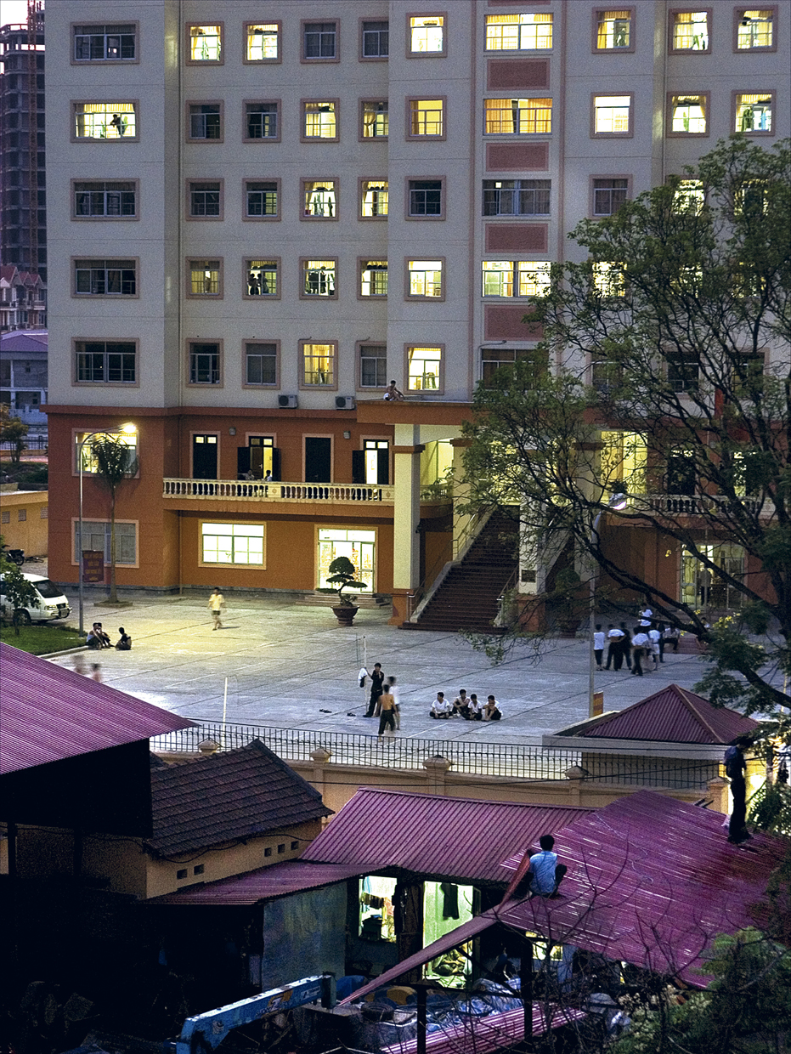

**Phượng M. Đỗ, “cảnh sau nhà anh long (view from cousin long’s apartment),” 2005, Lacquered photographic print. 14” x 19”. Courtesy of the artist.**

**Photography and its materiality and legacy**

Supported by the 2004-2005 Fulbright grant, *lacquered photographs* is a series of street photography taken in various cities such as Thái Nguyên, Hà Nội, and Hồ Chí Minh city, from 2000 to 2008. Captured are night and twilight sceneries of both quiet and dynamic corners of the urban life.

It is in the still of the night, in contrast to the noise of the day, that Đỗ found connection with Việt Nam. She was drawn to how vividly life emerged under the lights when publicity and privacy interlock. She played a guessing game in her mind, wondering what people thought as she wandered about the nightfall.

In this series, photography is complemented by lacquer. With the photographic print mounted onto a panel, then coated with ten layers of lacquer, the final product gleams with the protective shine unique to the latter medium.16

Đỗ found material and artistic parallels between the two. With its resin, lacquer provides long-lasting preservation as much as photography preserves the memory of the captured moment. Dealing with lacquer paint proves harmful to the health of the artists; so is developing analogue photography with chemicals. Moreover, the former produces highly priced goods but also coats mundane objects of daily use such as utensils, while photography is sometimes highly regarded, in the case of fine art, but also easily dispensable, as in vernacular photography.

Exemplified by *Found Photographs, Vietnam*, the latter category of photography is more prone to dispossession. Albeit personally intimate, exposure is what Đỗ felt these archival images have cried for. For a long time, the artist had called them “abandoned photographs”—in many senses, because they were physically and figuratively disowned and displaced from one hand to another. That was until an internal switch led her to make use of the collection which had been sitting around for ages. She saw them differently, as found photographs. Found by her, and to be found by the world. “I’m being a channel, and these things are talking to me in some ways.”

As a whole, this long-term project is a bridge that connects the past with the present and future: people in distant times get subjected to contemporary viewership, while our generations and those to come are teleported to a temporal space where histories are relived and stories unearthed. This is the preservative impulse of photography that can exceed the life expectancy of its creators or even its material duration, with today’s increasing technological saturation.

**Nature as Guidance of Peace**

Last but not least, *1460 days* is a diary-like project Đỗ started when Trump was elected as the 45th President of the United States. As the title suggests, this series spans across four years, compiling snapshots of everyday life, from wildlife, mountains, oceans, deserts to crowded streets, festivals, buildings, tourist attractions, and family. Nothing experimental or conceptual but a pure practice of composition and framing that one might think any dedicated camera holder does. Each day, a single or a hoard of photos, sometimes videos, got uploaded to [an Instagram account](https://www.instagram.com/1460daysusa/) dedicated to the project.

What mattered was the consistency to make photographs, a routine for her to find peace of mind amidst the political shift in America. “It was a traumatic moment,” she recalled. Documenting whatever intrigued her started out as a short-term activity to cope with her disappointment, eventually expanded into a daily habit as it became “nourishing.”

“It really was about being in the moment, and seeing things and living basically, day to day, and being there.”

Photography is not only the bridge Đỗ attempted to cross in order to patch what had been torn—identity, family, culture—but also her meditation, like a “Buddhist practice.” This extends to her current philosophy about the medium in general: when doing photography, one has to be present because one only takes photographs of subjects to which one feels connected.

Furthermore, *1460 days* helped the artist reform her bond with nature, its underlying theme. Most of the photos are snippets of natural life performing their daily rituals in the wild, making small yet collectively grand impacts on humanity, who appears minuscule in comparison.

So are the storms one cannot contain. There are events in life that, for Đỗ, are out of reach and beyond control. If all has been done, let it be.

**Life/Photography as a Puzzling Struggle**

“Most of my life is trying to put the pieces back together. The many different pieces. What I wanted to do with photography was to deal with that.”

The themes of displacement, intergenerational and intercultural issues, and connection recurred throughout our Zoom conversation. In today’s time, the political and sociocultural phenomena elbowing for priority on headlines are definitely different from when Đỗ first set foot in photographic artistry. Environmental crisis, political disorder, civil strife, global health disaster, and the list goes on.

For those who are privileged to be able to sit down and enjoy art during the pandemic, life has been harsh. For others whose livelihood has been constantly put under increasing inequality, life is more intolerable. At some points, we all feel lost and despair.

Though torn apart as we are, we have to make choices for our life, even when there are few to none as the current situation insists that one makes do with what one has. And to find what fits and what does not is a life-long learning process that requires one to constantly change, reflect, and grow.

When asked about her view on identity, Đỗ referred to it as a “jacket.” To be something, someone, from somewhere, is to put on a garment, whether that is your choice or an influence.

“I just don't feel like I can say I'm Vietnamese, or I'm Vietnamese American. […] I'm a citizen of the United States so just call me American. But you look at my face, and you decided that I'm not American. So that's as long as society wants to put you in certain boxes. That question always is up to someone else.”

As such, choosing your label(s) is a process of growth in itself. With the advancement of identity politics in the past decades, for many parts of the world, one has had a better chance to navigate who they are. For Đỗ, it is letting go of confrontation and focusing on herself.

“I guess the difference of that question [*what makes you Vietnamese?*] from 20 years ago to now is that I don't care as much—whether I'm Vietnamese or not. I used to care that I need to know. I need to know if I have this connection to Việt Nam and that I am part of this thing. This identity. But now, it's not so important. Because I think if it's still so important, then I don't think I have grown in terms of understanding who I am.”

Đỗ uses photography as a thread to tie knots, a scissor to cut ties, and a compass to seek peace of mind. With each project comes along a puzzle to solve. A jigsaw one, with her moving around the game to see what fits and what does not.

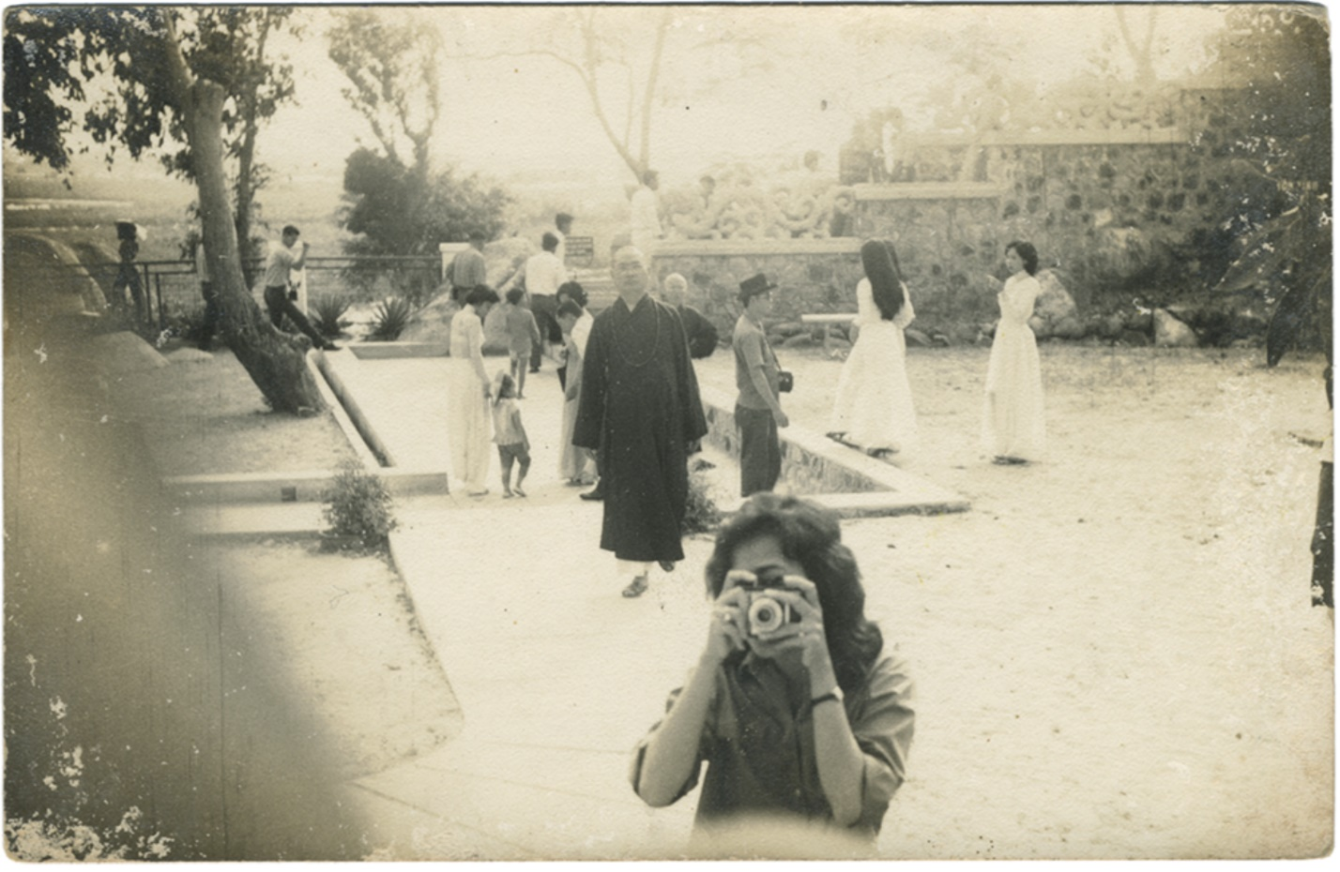 **Phượng M. Đỗ, *untitled*, Digital scan, part of *Found photographs, Vietnam* (ongoing). Courtesy of the artist.**

**Notes**

I would like to thank Đỗ Mỹ Phượng and Nora Taylor for their time, patience with, and wisdom in our long Zoom conversations. I would also like to express my earnest gratitude towards Nabilah Said for all the mentorship, patience, and help, as well as ArtsEquator’s Executive team and Goethe Institut Singapore for facilitating this virtual residency. Writing this piece would be impossible if it had not been for these humans and this initiative.

This article continues my ongoing research on self-identified female art professionals in/from Việt Nam and its diaspora. As one thing I have come to realize during this residency, writing as well as research is a process of constant revisions.

Thank you for reading thus far! Please write to me at [donghanhuan@gmail.com](mailto:donghanhuan@gmail.com) if there are any inquiries and feedback regarding this article or just to connect!

1. View the Vietnamese version of the article [here](https://luxuo.vn/culture/luoc-khao-ve-nghe-thuat-duong-dai-viet-nam-qua-chan-dung-cua-hon-20-guong-mat-nu-tieu-bieu.html). The bilingual version with English translation is currently available exclusively in Art Republik Vietnam’s issues 1 and 2.

2. The act of lumping together female artists to showcase their work collectively is contested. While some might argue for it, others criticize it for enhancing the male-dominant narrative or reducing them to mere gender. In retrospect, my article is introductory and targeted at the general public, hence its categorization in terms of artistic practices and careers, including multimedia; photography and film; theater, dance, music and sound art; curator and researcher; arts administrator and collector. I could have engaged a more in-depth discussion of the figures’ practices, although I did not merely present a list but order the appearance of art practitioners in consecutive thematic flows. In that article as well as this one, I also take for granted some contested terminologies, including but not limited to, “Vietnamese,” “Vietnamese contemporary art,” and “female” or “women.”

3. [Nora Annesley Taylor](https://www.saic.edu/profiles/faculty/nora-annesley-taylor) is an established researcher of Southeast Asian art who has written extensively on the local art scene in Việt Nam. She is Alsdorf Professor of South and Southeast Asian Art History (2007) and currently teaches at the School of the Art Institute of Chicago, U.S.A. Her publications include *Painters in Hanoi: An Ethnography of Vietnamese Art* and co-edited monographs, *Modern and Contemporary Southeast Asian Art, An Anthology*, *Le Vietnam au Feminin*, *Studies in Southeast Asian Art History: Essays in Honor of Stanley J. O'Connor*. Her writing has appeared in Art Journal, Arts Asiatiques, Third Text, Journal of Vietnamese Studies, Ethnos, Michigan Quarterly Review, Crossroads, Flash Art, Asian Art News. She is also a curator, with exhibitions such as *Breathing is Free: 12,756.3, Recent Work by Jun Nguyen-Hatsushiba* (2009); *Changing Identity: Recent Work by Women Artists from Vietnam* (2005–2009, travelling); *Blue Memory: Tran Trong Vu* (2004); *Post-War Vietnamese Art: Paintings from the Collection of Bruce Blowitz/Albert Goodman* (2016); John David Mooney Foundation, Chicago, 2016. Some of her awards include the 2014–2015 John Solomon Guggenheim Fellowship, the Getty Collaborative Research Award in 2009, and a Fulbright Grant through which she met Phượng M. Đỗ for the first time.

4. The ten artists are: Nguyễn Bạch Đàn (who unfortunately passed away in 2012), Đinh Thị Thắm Poong, Nguyễn Thị Châu Giang, Lý Trần Quỳnh Giang, Đinh Ý Nhi, Đặng Thị Khuê, Phượng M. Đỗ, Ly Hoàng Ly, An-My Lê, Vũ Thu Hiền.

5. Nora A. Taylor, “Themes and Concerns in the Works of Vietnamese Women Artists,” in *Changing Identity: Recent Works by Women from Vietnam* (Washington, DC: International Arts & Artists, 2007), 74-78.

Taylor admitted that she had received criticisms of the exhibition because of the all-women curatorial approach, although she insisted it was not her intention. As a precursor, she had come to realize in her field trips to Việt Nam in the 90s was that women artists often, at the time, either subconsciously or intentionally, took up an inferior space in the artists’ households and conversations. They would serve tea, then retrieve to a dedicated space “behind the curtains,” so to speak, as Taylor recalled; when asked, they would speak lightly of their own artistic practices as if only the men’s (their spouses’) were worth mentioning and discussing, not their own. “The art world was very masculine,” as the scholar noted in our conversation. Bringing together female artists, local and diasporic alike, meant challenging such a male-biased, male-dominant norm she had witnessed. See Nora A. Taylor, “Women Artists,” in *Painters in Hanoi: An Ethnography of Vietnamese Art* (Honolulu: University of Hawaii Press, 2009), 94-107.

6. According to my interview with the artist; Phượng M. Đỗ, “[Phuong Do: MA’ 02, Studio Art](https://as13x.es.its.nyu.edu/profiles/alumni/phuong_do),” Featured Alumni Profiles, NYU Steinhardt, New York University; and the artist’s LinkedIn profile. All quotes by Đỗ in this article are cited from our conversation, unless otherwise noted.

7. She felt as if she was “jumping rope.” “It's like waiting, waiting. And then you just go in. And once you go in, it's okay. But if you keep waiting, it's really scary, right?”—she told me.

8. About the issue of the hyphenated identity of Asian communities in the U.S., see Henry Fuhrmann, “[Drop the Hyphen in Asian American](https://consciousstyleguide.com/drop-hyphen-asian-american/),” Conscious Style Guide.

9. Trịnh T. Minh-Hà, *Women, Native, Other: Writing Postcoliniality and Feminism* (Indianapolis: Indiana University Press, 1989), 119-21.

10. Ibid, 121.

11. It is widely accepted that the war occurred between 1954—the year that Điện Biên Phủ Battle, or *Chiến dịch/Chiến thắng Điện Biên Phủ*, put an end to the First Indochina War, or *Kháng chiến chống Pháp* / *Chiến tranh Đông Dương (lần 1)*; the Geneva Accords divided Việt Nam into the North and the South at the 17th parallel; the ceasefire of France in Indochina—and 1975—the year of the Fall of Sài Gòn, or *Giải phóng miền Nam*, on April 30th; the withdrawal of American personnel and some South Vietnamese allies from Việt Nam; the national reunification of Việt Nam, or *Thống nhất đất nước*.

12. Nora A. Taylor, *Changing Identity*, 63.

13. Đỗ had been storing these archival images for nearly two decades. In the early 2000s, while making the second part of *self + family*, which was never published, she visited “qua bến nước xưa” (or “crossing waters of the past,” as Đỗ translated), a collaborative installation by Sue Hajdu and Đỉnh Q. Lê. See Phượng M. Đỗ’s blog post “[Afternoon Sun](https://www.foundphotographsvietnam.com/post/afternoon-sun)” on her project site “Found photographs, Vietnam”; “[Qua Ben Nuoc Xua: An Installation by Sue Hajdu and Dinh Q. Le](https://aaa.org.hk/en/collections/search/library/qua-ben-nuoc-xua-an-installation-by-sue-hajdu-and-dinh-q-le),” Collections, Asia Art Archive.

14. As Đỗ was dealing with SEO issues of her project site, what came up for a search of the site’s title was related to Vietnam War. “That’s how deep it is in terms of representation and what is understood, and how it gets into the narrative of a culture,” she noted.

15. Phượng M. Đỗ, “[Le Cong Kieu Street](https://www.foundphotographsvietnam.com/post/le-cong-kieu-street),” on her project site.

16. For more information, see “About the Exhibition” in *Made in Vietnam: Photography by Phuong M. Do* (New York: NYU Gallery Space of Wagner, 2009), 6-11.

**Bibliography (For further reads)**

Cheng, Anne Anlin. “[Yellow Skin, White Gold](https://aaa.org.hk/en/ideas/ideas/yellow-skin-white-gold).” IDEAS, Asia Art Archive, Jan 9, 2020.

Đồng, Nhuận H. “Chân Dung của Hơn 20 Gương Mặt Nữ Tiêu Biểu” [2020 Tribute: An Extensive List of

20+ Female Figures in Vietnamese Contemporary Art] (bilingual). Published in two parts. *Art Republik Vietnam* 1 (2020): 203-213; *Art Republik Vietnam* 2 (2021): 192-201.

Kim, Elaine H., Margo Machida, and Sharon Mizota, eds.. *Fresh Talk/Daring Gazes: Conversations on*

*Asian American Art*. Berkeley: University of California Press, 2020.

Kwon, Miwon. “Flash in the East, Flash in the West.” In *The Migrant’s Time: Rethinking Art History and*

*Diaspora*, edited by Saloni Mathur, 196-205. Williamstown: Sterling and Francine Clark Art

Institute, 2011.

Lee, Weng Choy. “[Criticism and ‘the Essence of Contemporary Asian Art’](https://aaa.org.hk/en/ideas/ideas/criticism-and-the-essence-of-contemporary-asian-art).” IDEAS, Asia Art Archive,

May 1, 2004.

Pelaud, Isabelle Thuy, Lan P. Duong, Mariam B. Lam, Kathy L. Nguyễn, eds. *Troubling Borders: An*

*Anthology of Art and Literature by Southeast Asian Women in the Diaspora*. Washington:

University of Washington Press, 2020.

Taylor, Nora Annesley. *Changing Identity: Recent Works by Women Artists from Vietnam*. Washington,

DC: International Arts & Artists, 2007. Published in conjunction with a traveling exhibition of the

same title.

Taylor, Nora Annesley. *Painters in Hanoi: An Ethnography of Vietnamese Art*. Honolulu: University of

Hawaii Press, 2009.

Taylor, Nora Annesley and Pamela Nguyen Corey. “Đổi Mới and the Globalization of Vietnamese Art.”

*Journal of Vietnamese Studies* 14, no. 1 (2019): 1-34.

Trịnh, T. Minh-Hà. *Women, Native, Other: Writing Postcoloniality and Feminism*. Indianapolis: Indiana

University Press, 1989.

Wong, Mimi. “[The Aesthetic Project of Remaking ‘Yellow’ Identity](https://aaa.org.hk/en/ideas/ideas/the-aesthetic-project-of-remaking-yellow-identity/type/essays).” IDEAS, Asia Art Archive, April 20,

2020.

Zhuang, Wubin. *Photography in Southeast Asia: A Survey*. Singapore: NUS Press, 2016.